**IBM CP4Data – Hands-on Lab**

# **Data Virtualization**

Contents

**Data Virtualization** 1

**Section I** 4

**Provision Data Virtualization** 4

pre-requisites 4

**Section II** 6

**Lifecycle of Data Virtualization** 6

1. Manage users 6

2. Add data sources 10

3. Create virtual assets 12

4. Create a joined view 14

5. Assign assets to a project 17

6. Collaborate with various user personas 18

7. Approve Data Requests 21

Bonus 25

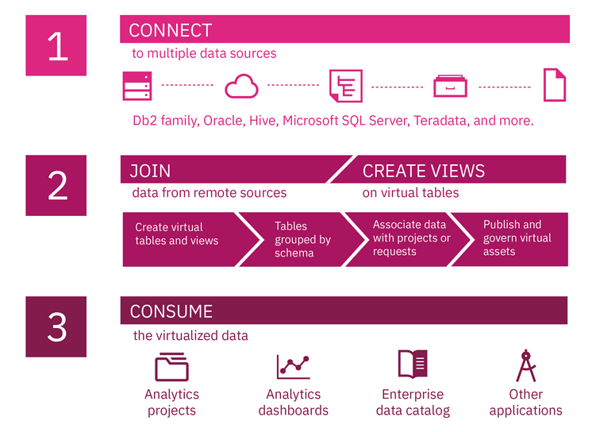

As seen in above diagram, Data Virtualization feature allows users to consume data assets from one single point either as is or through pre-defined joins and views.

# **Section I**

# **Provision Data Virtualization**

(This step is performed only once, it has been done in your environment already) Use these as guideline for your own environment in future.

In this section we will:

* Provision Data Virtualization instance
* Provision Storage

## pre-requisites

* IBM Cloud Pak for Data instance is already installed and available
* The process requires that there is at least one node available in the IBM Cloud Pak for Data cluster with the following minimum requirements:
  + Cores: 6 available cores
  + Memory: 16GB of available memory
  + Local Storage: 100GB

To provision the data virtualization add-on:

1. Click the Add-ons icon (Add-ons icon) from the IBM Cloud Pak for Data web user interface.
2. From the list of add-ons, locate the Data Virtualization panel and click the action menu.
3. Select Provision instance.
4. Configure the add-on:
   1. In the Configuration section, specify the resources that you want to allocate to the add-on:
      1. Specify the number of cores to allocate to the add-on. You are constrained by the total number of available cores on the node. If your node has 16 available cores, you can specify up to 16 cores. The maximum number of cores you can specify is 64.
      2. Specify the amount of memory to allocate to the add-on. You are constrained by the total amount of memory on the node. If your node has 32 GB of memory, you can specify up to 32 GB. The maximum memory you can specify is 512 GB.
      3. In the Storage section, specify the storage that you want to use for the virtual tables:
      4. If you want to use a storage class to create a new persistent volume, select Storage class. Then, select the storage class to use and specify the amount of storage to allocate to the persistent volume.
      5. If you want to use an existing persistent volume claim, select Claim name. Then select the persistent volume claim that you want to associate with the add-on.
      6. In the Local storage field, specify the path of the storage partition that you created on the worker nodes.
5. Click Next.
6. Ensure that the summary is correct and click Provision.
7. It can take approximately 10 minutes for the service to be provisioned. If you want to use IBM Cloud Private for Data while you wait for the deployment to complete, click Home.

# **Section II**

# **Lifecycle of Data Virtualization**

In this section we will perform full lifecycle of data virtualization process, that include:

## Manage users

There are three user roles defined for data virtualization. These roles are specific to the data virtualization environment and are granted to existing IBM Cloud Pak for Data users. In order for a user to have access to the data virtualization service, you must assign them one of the following data virtualization roles:

* Data Virtualization Admin
* Data Virtualization Engineer
* Data Virtualization User

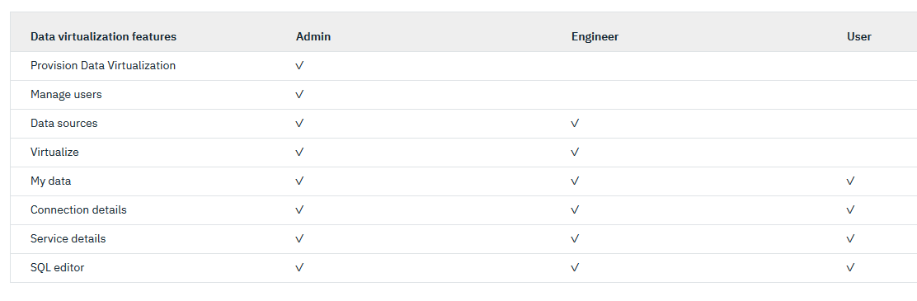

Important: If Data Virtualization Admins or Engineers submit requests to publish virtual tables or views to the enterprise data catalog, you must give at least one IBM Cloud Pak for Data - data steward access to the data virtualization service as a Data Virtualization Engineer.

If you don't use the default IBM Cloud Pak for Data roles, you must give at least one user with the **Manage catalog** permissions access as a Data Virtualization Engineer. The user who processes the requests to publish tables and views to the enterprise catalog must have this access to get the required metadata about the tables and view.

Read more here <https://www.ibm.com/support/producthub/icpdata/docs/content/SSQNUZ_current/cpd/svc/dv/dv_overview.html>

* 1. Add the ICP for data platform “Data Engineer” user as “Engineer” in DV
     1. Login to ICP4D instance using credentials provided ( as admin role user)
     2. Click on Navigation menu on top left corner. Click on “Collect” and then “Virtualized data” option

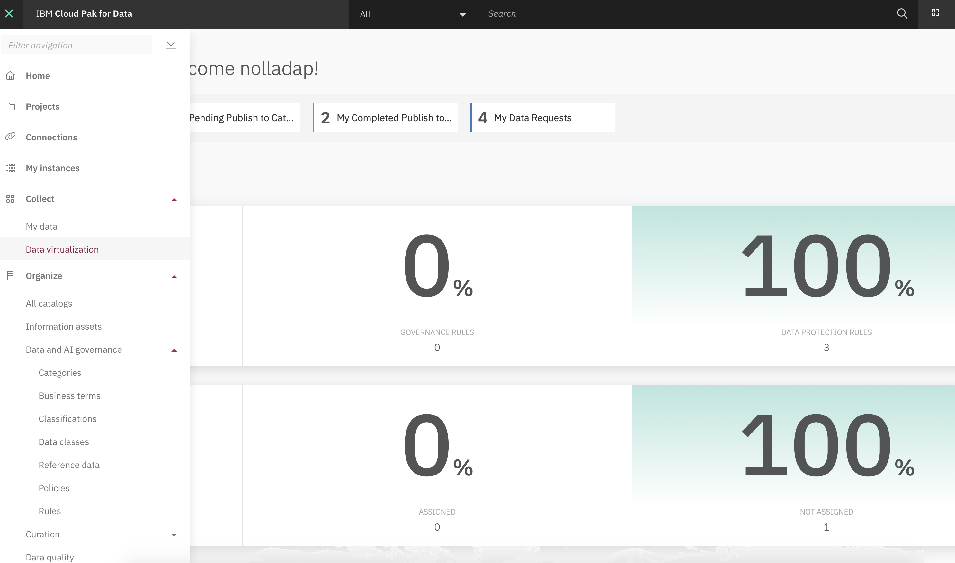

* + 1. This will bring up “Data virtualization” screen as shown below.

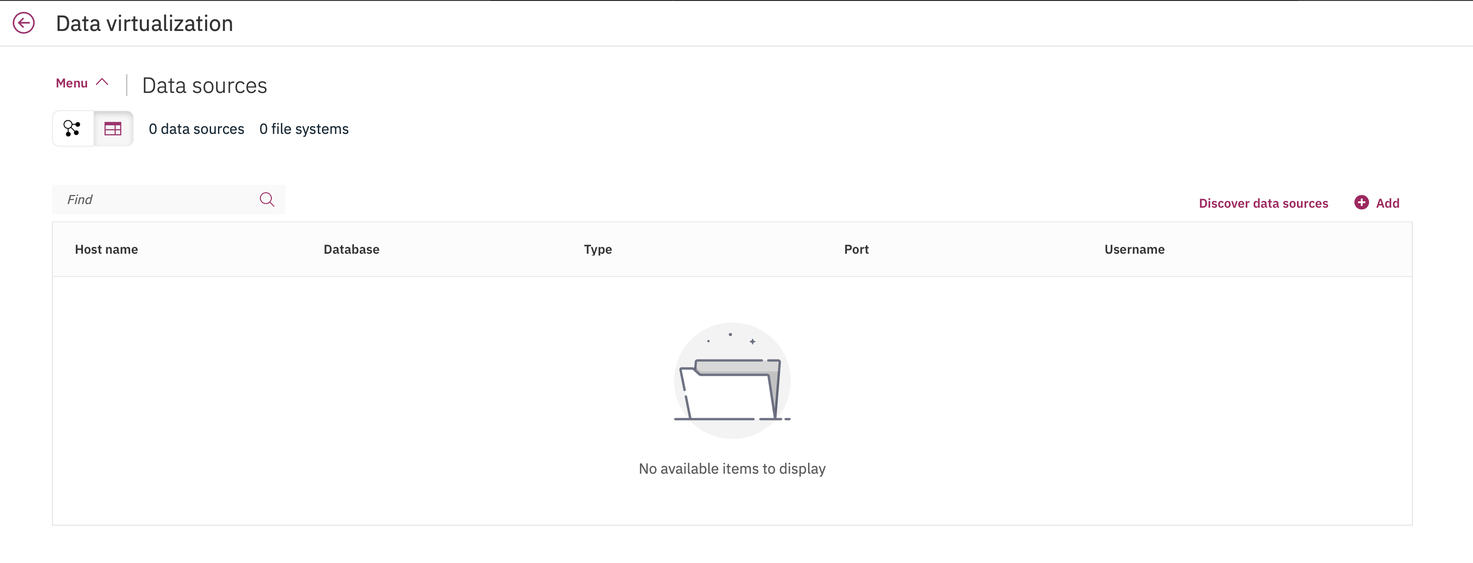

* + 1. Click on “Menu” option on top right corner. This will show all options within Data virtualization feature, as shown below:

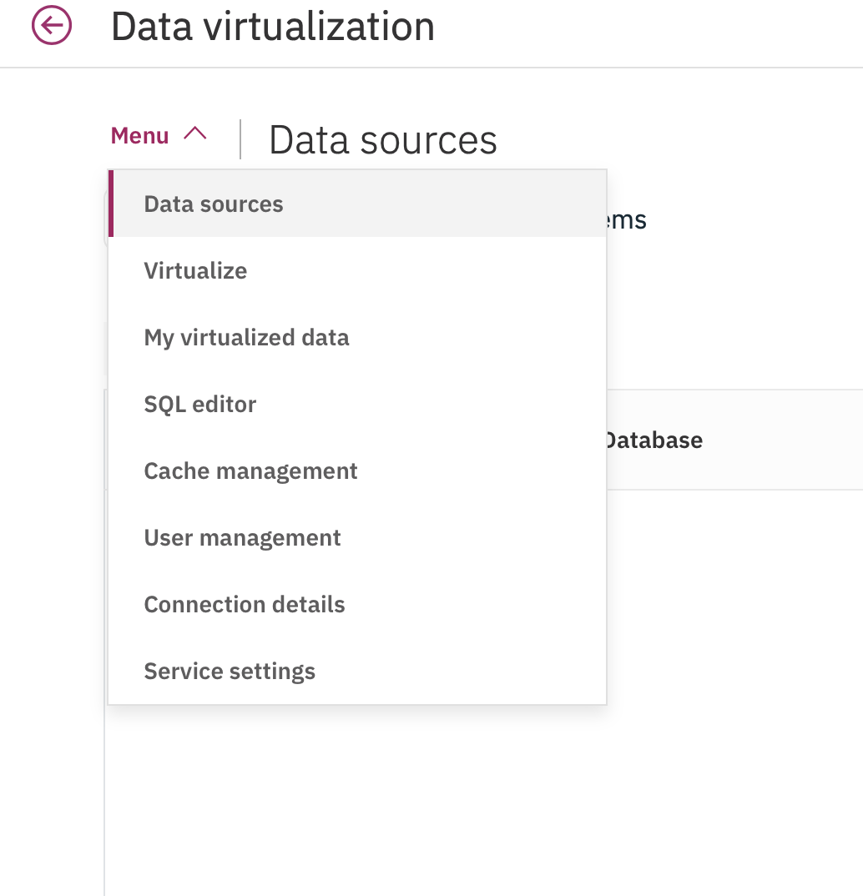

* + 1. Click on “User management” option. The ICP for Data platform users must be defined before we provision a user access to Data virtualization (DV) feature. In order to add user to DV, click on “Add users” option on right hand side, below “Menu” option:

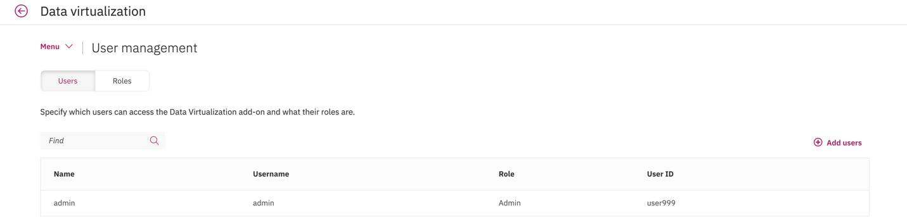

* + 1. This will bring up ADD USERS screen as show below:

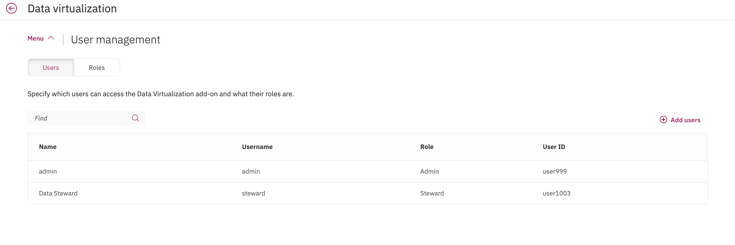

* + 1. Click on check box left of Name column , for e.g. “nolladap” and select from drop-down list under “Role” as “Engineer and click “Add”:

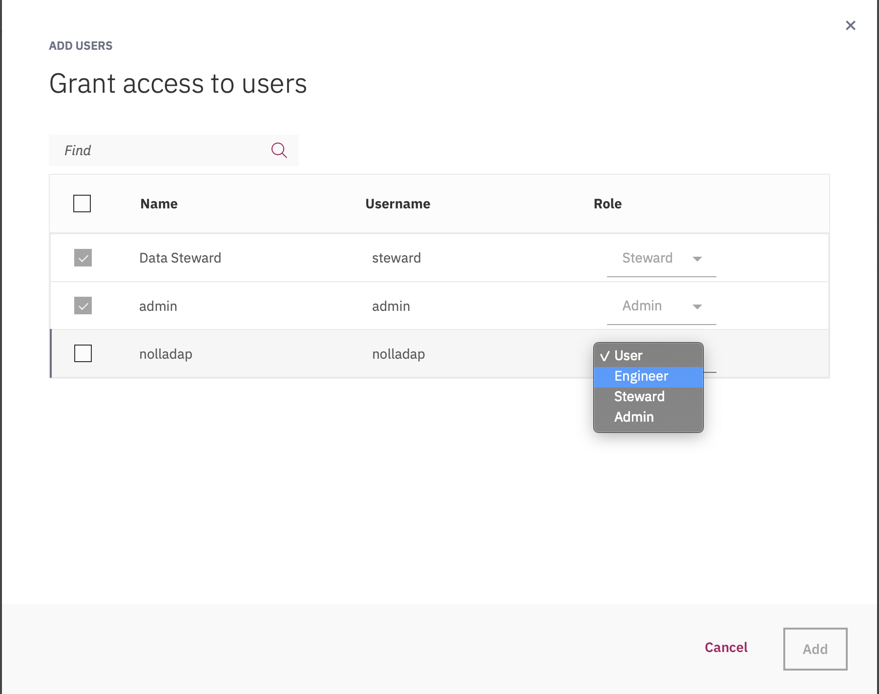

* + 1. This bring up the Managed users screen with newly added use information, as show below:

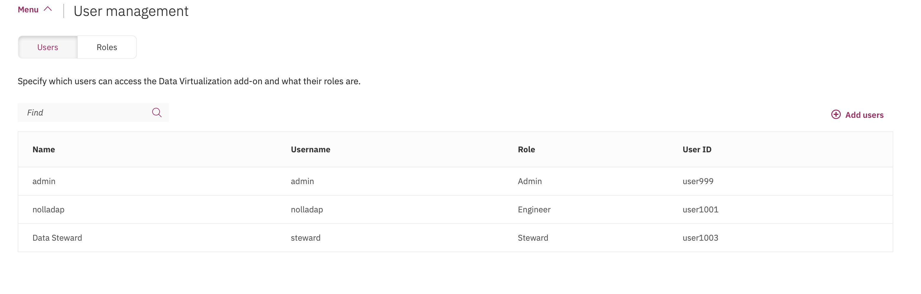

* 1. Add the Data Scientist user as User with in DV
     1. Follow 1.1.5 to 1.1.8 steps and chose “User” Role . Select any available user in ICP for Data with “Data Scientist” role.
  2. Add the Data Steward user as Engineer
     1. Follow 1.1.5 to 1.1.8 steps and chose “Engineer”. Select any available user in ICP for Data with “Data Steward” role.

## Add data sources

Data Virtualization supports many relational and non-relational data sources that you can add to your data source ecosystem. Data Virtualization agents connect to relational data sources using the Java Database Connectivity (JDBC) protocol. The credentials used to establish the connection to the data source determine what data in the data source can be accessed by the Data Virtualization agent.

* 1. Click on Home menu “**Collect**” option, then click on “**Virtualized data**”. This will bring DV screen. Click on “**Menu**” and then on “**Data sources**”

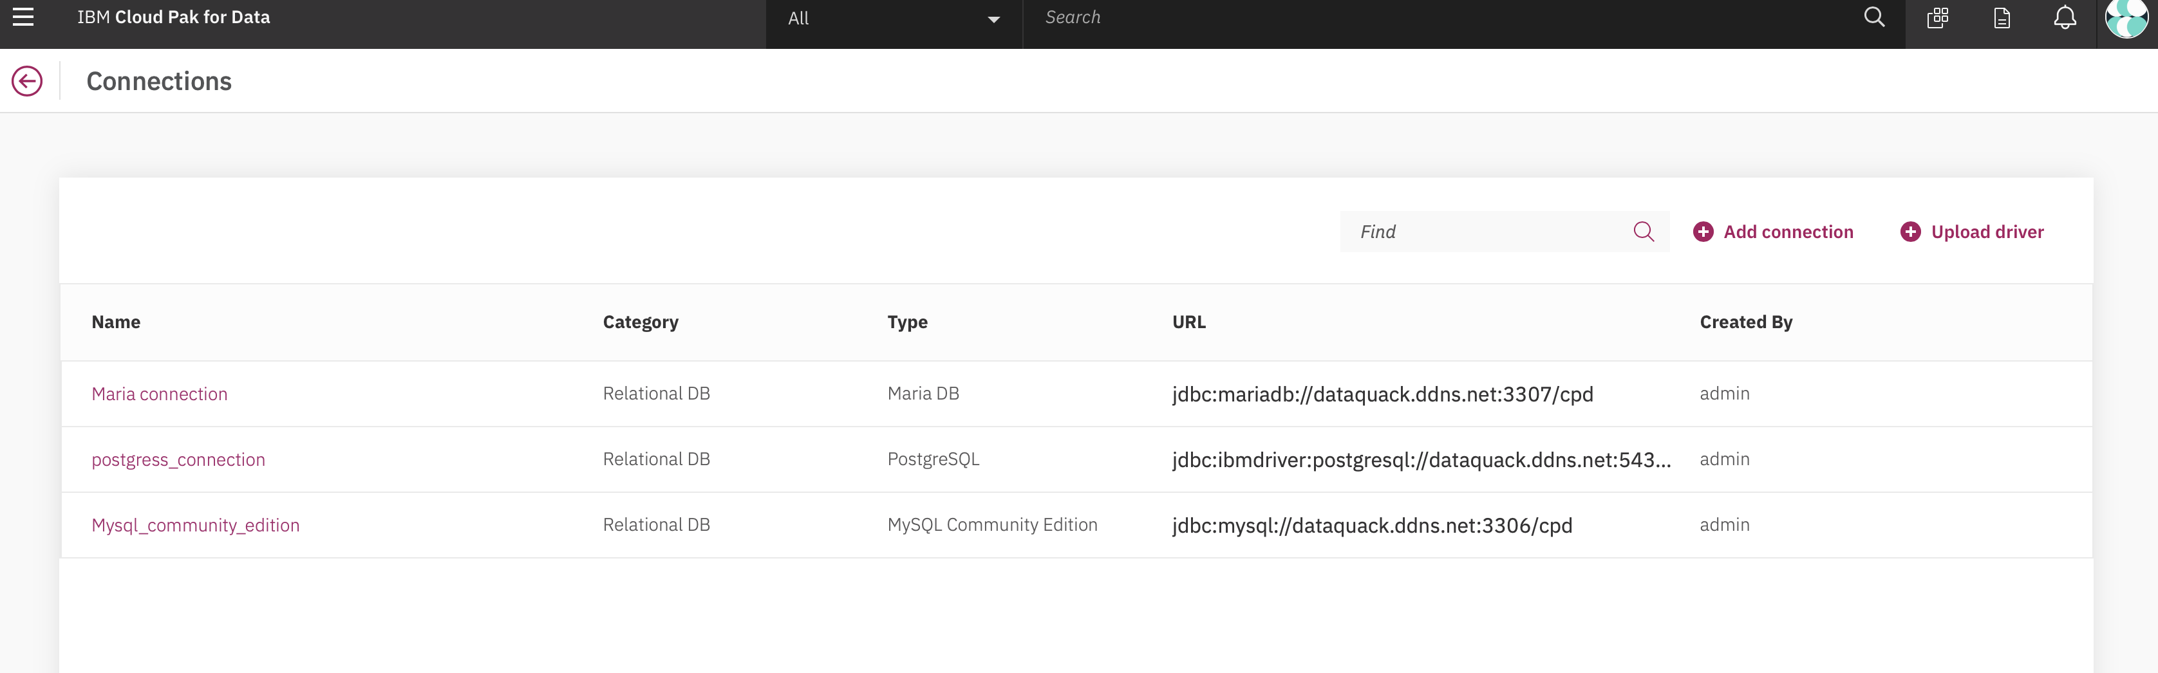

* 1. Click on “**Add connection**”. Enter name and type of data source. For e.g. as shown below for db2warehouse on cloud. Click on **Test Connection** option and then click on **Add** to save the connection.

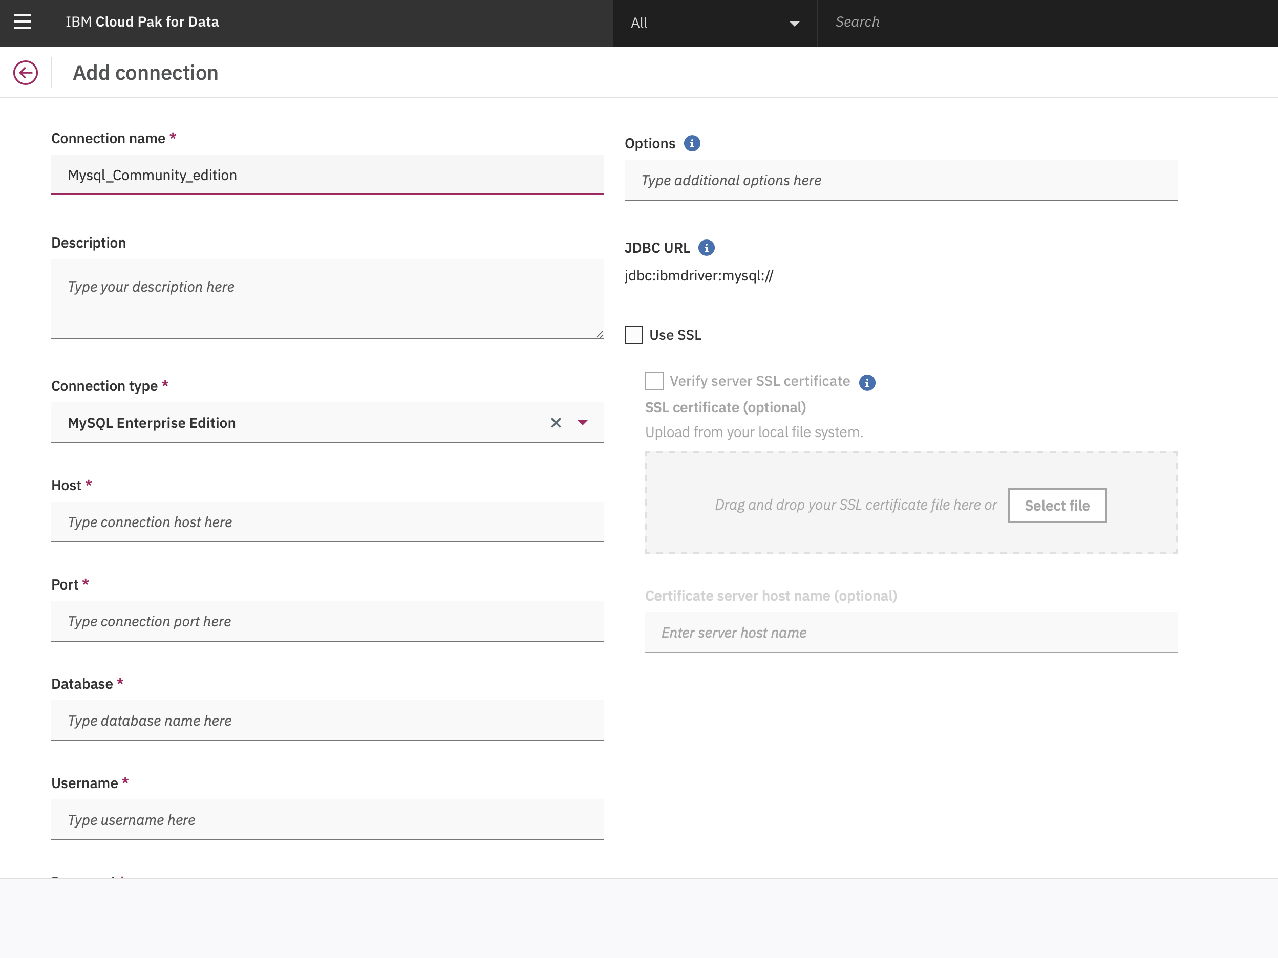

Host name: dataquack.ddns.net

Connection Type: Mysql Community Edition

Port number: 3306

Database name: cpd

User ID: cpd

Password: DataDuck!

* 1. The resulting page will show newly added data source as shown below :

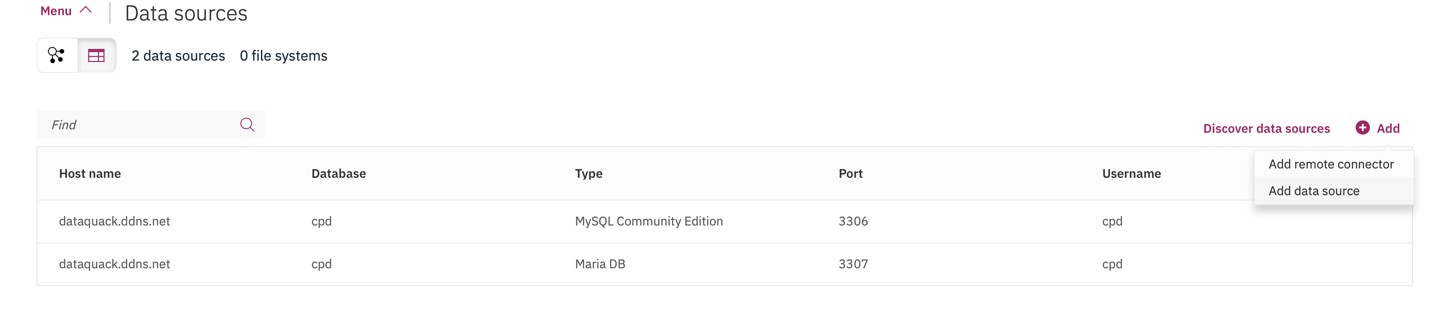

## Create virtual assets

The most common mechanism for virtualizing data is to create a table "view" or virtual table. You can create a virtual table to segment or combine data from one or more tables. Tables that are similar from multiple source can be combined into a single virtual table, which will create a unified definition containing the columns and data from all participating data sources. Segmentation can be vertical (either a subset or superset of columns based on a selection of chosen columns) or horizontal (an explicit set of rows or records based on a conditional expression) or both. You can then run queries against the resulting virtual table no different than how you would query any of the base tables.

* 1. Click on Home menu “**Collect**” option, then click on “**Virtualized data**”. This will bring DV screen. Click on “**Menu**” and then on “**Virtualize**”

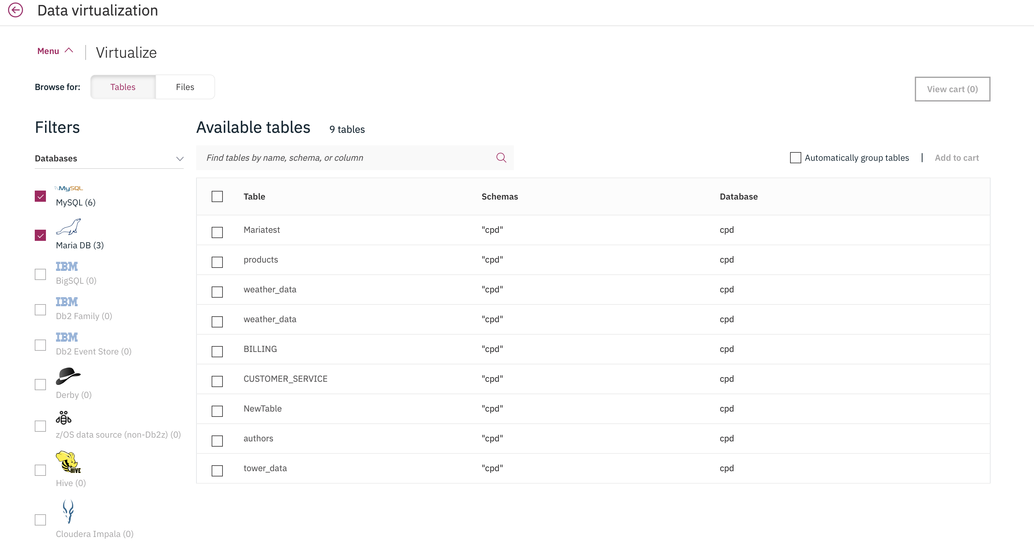

* 1. Click radio box to select BILLING and CUSTOMER_SERVICE tables that reside in mysql connection

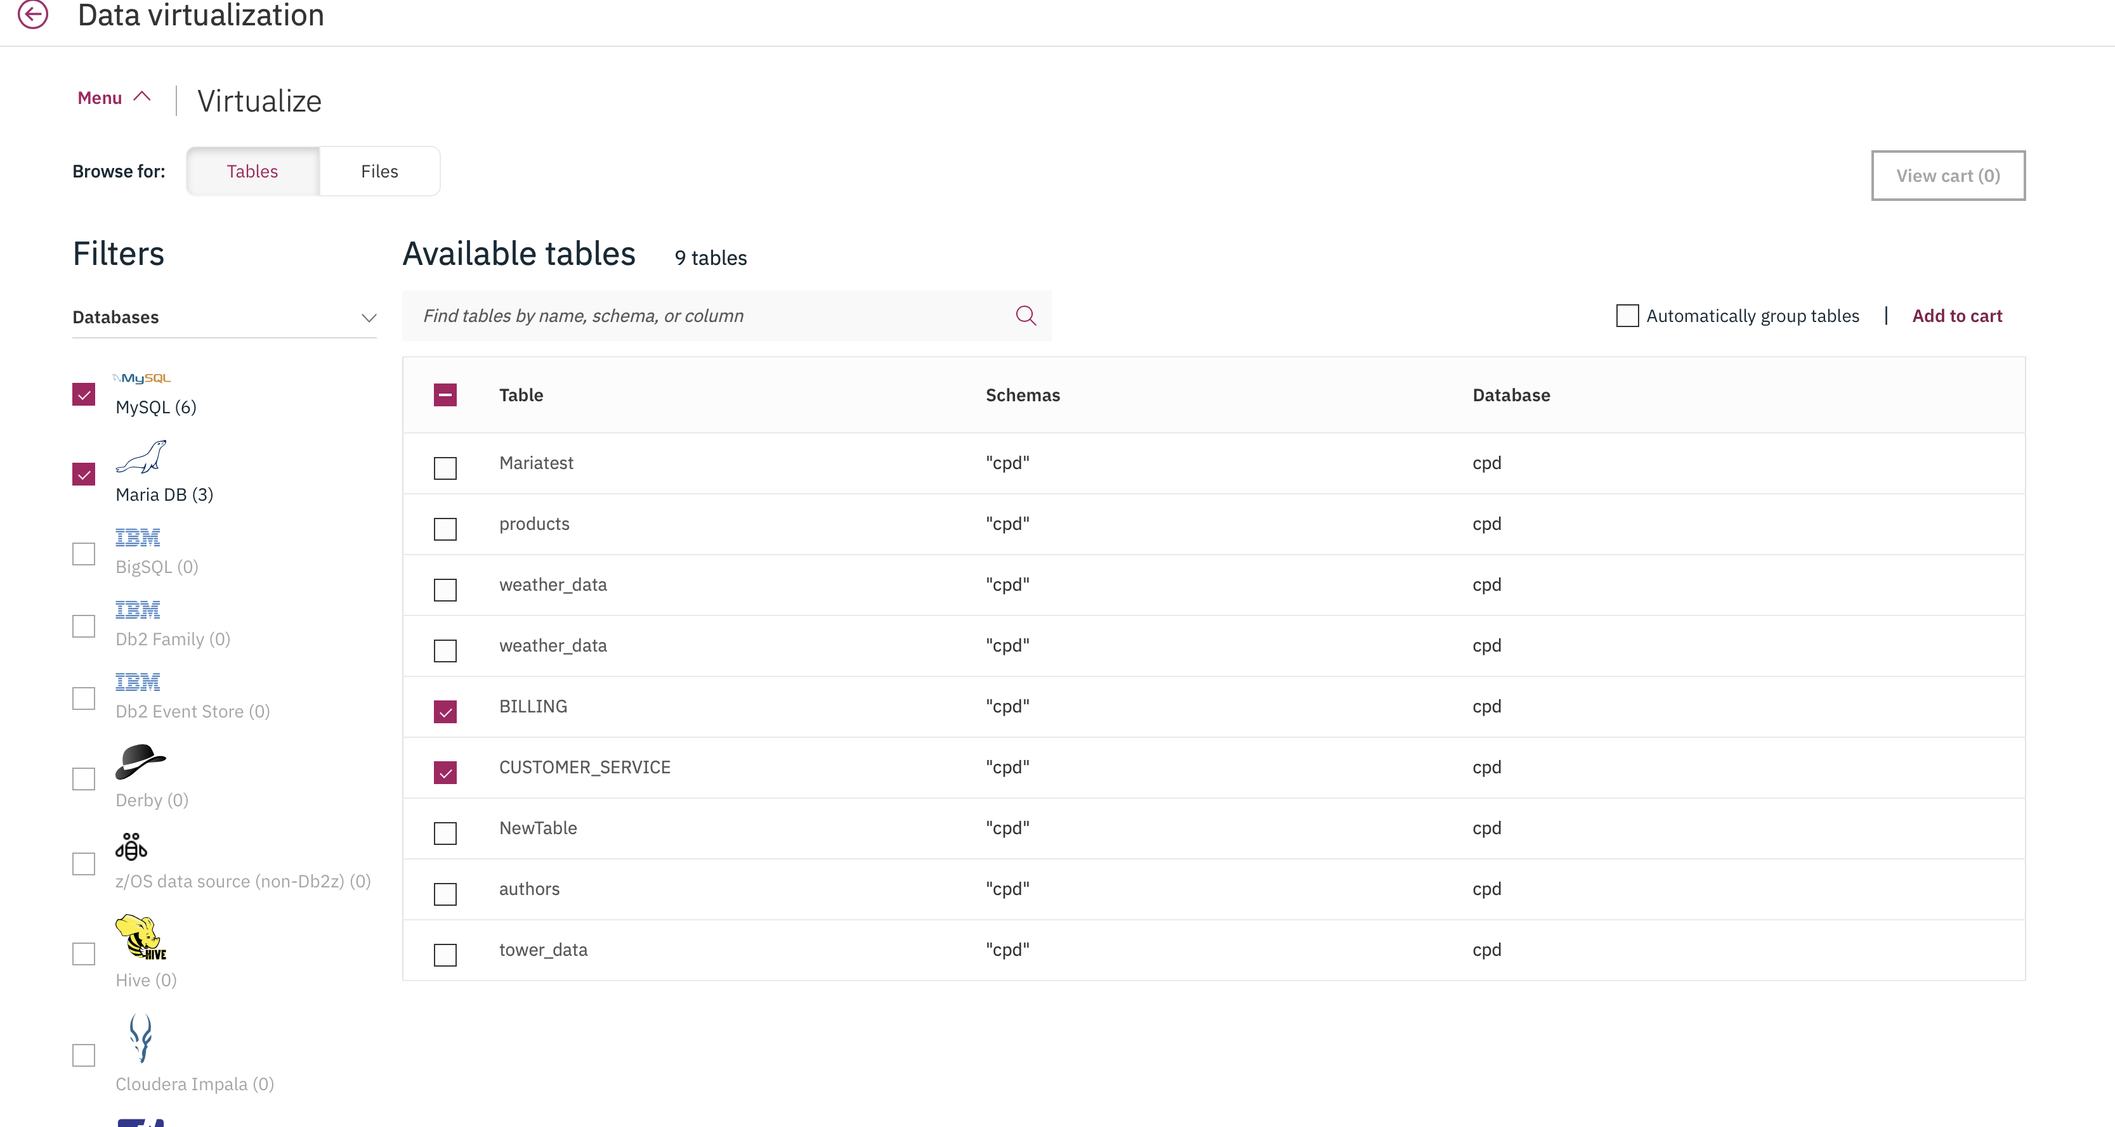

* 1. Click on “Add to cart”
  2. Click on View cart (2). This will show selected tables in your shopping cart.

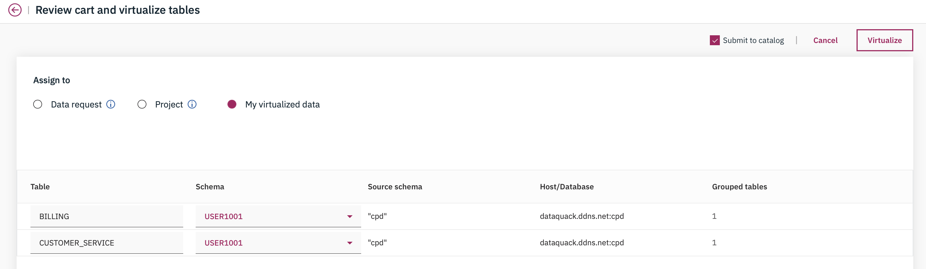

* 1. Change the schema to USER999 and click “Create” option next to it: (optional)
  2. Select My virtualized data
  3. Select “No” under Publish to catalog option
  4. Click Virtualize

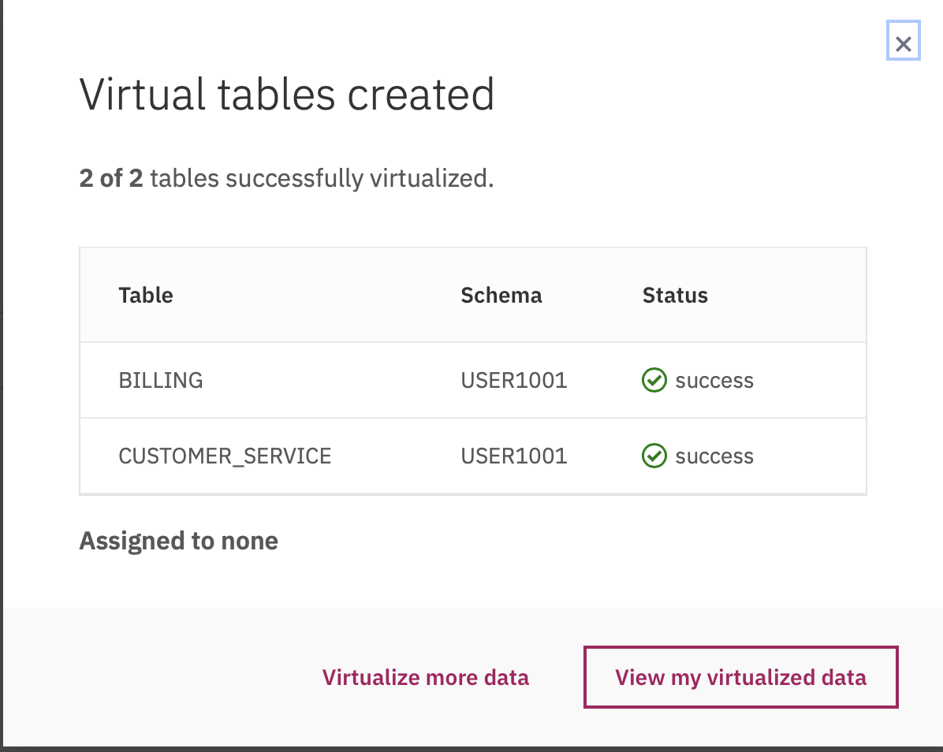

## Create a joined view

* 1. Click on Home menu “**Collect**” option, then click on “**data Virtualization**” . This will bring DV screen. Click on “**Menu**” and then on “**My virtualized data**”

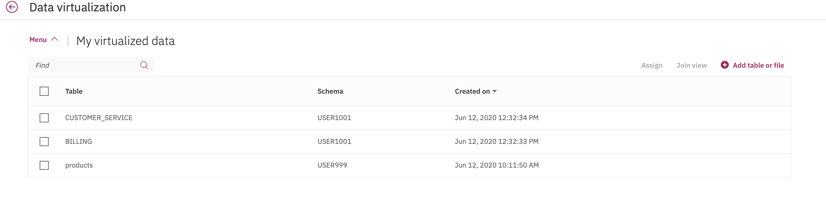

* 1. Select BILLING
  2. Select CUSTOMER_SERVICE

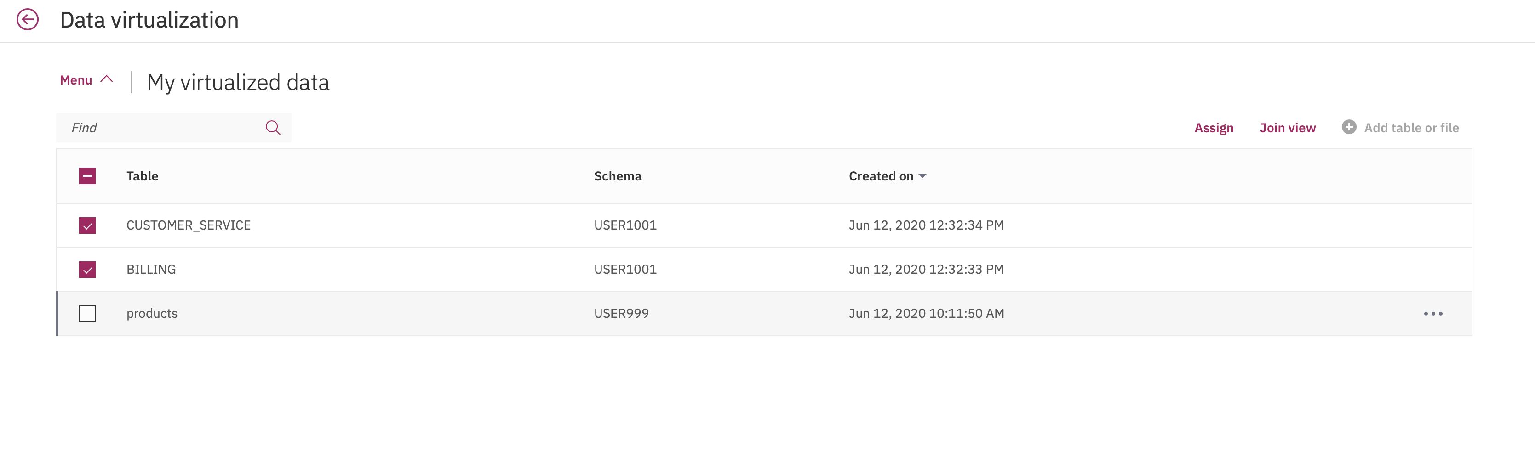

* 1. Click Join view. This will bring up both tables schema side-by-side with option to drag connection to identify joining column/s. Click in the CustomerID column area of BILLING table and drag while holding left mouse button and bring it over CustomerID column on CUSTOMER_SERVICE table area.

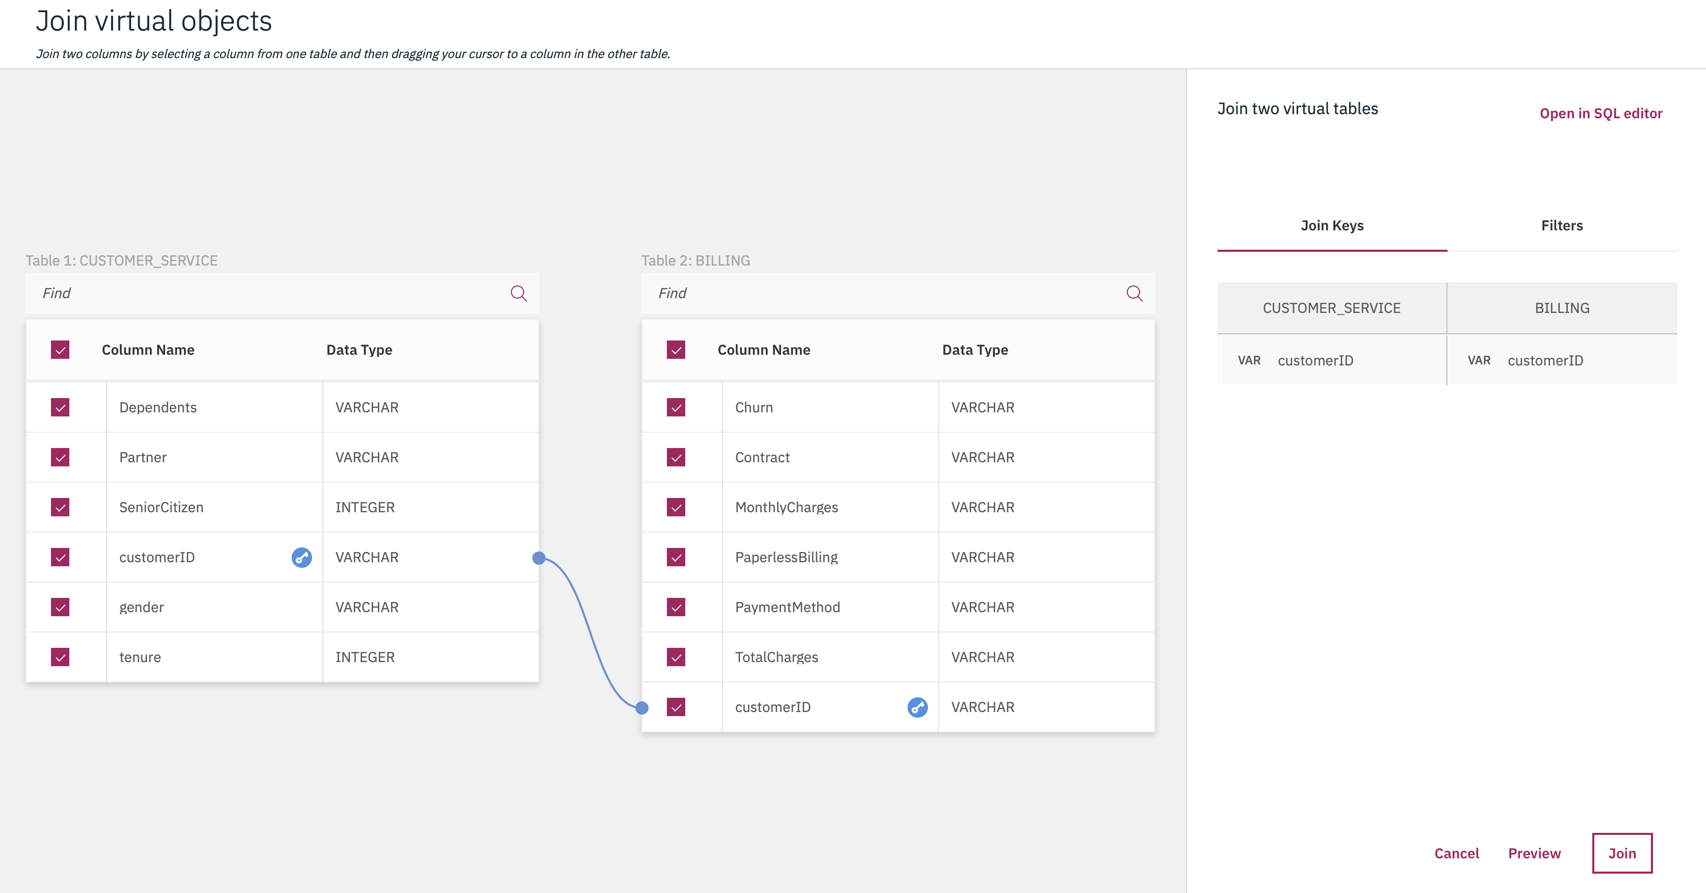

* 1. Click Preview to see that the CUSTOMER_SERVICE column shows up with the BILLING columns

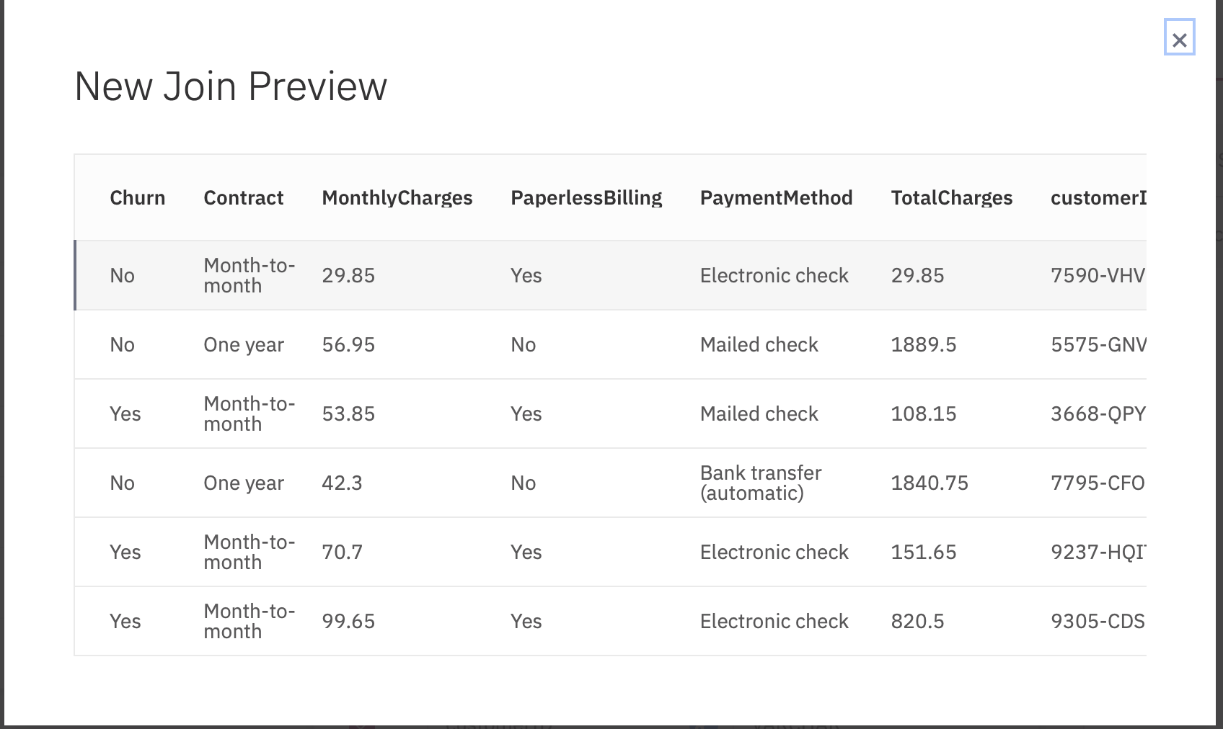

* 1. Click on “Join” . This will bring a join Review screen where you can enter the name for the new joined virtual table. Enter in the name JOIN_V1.

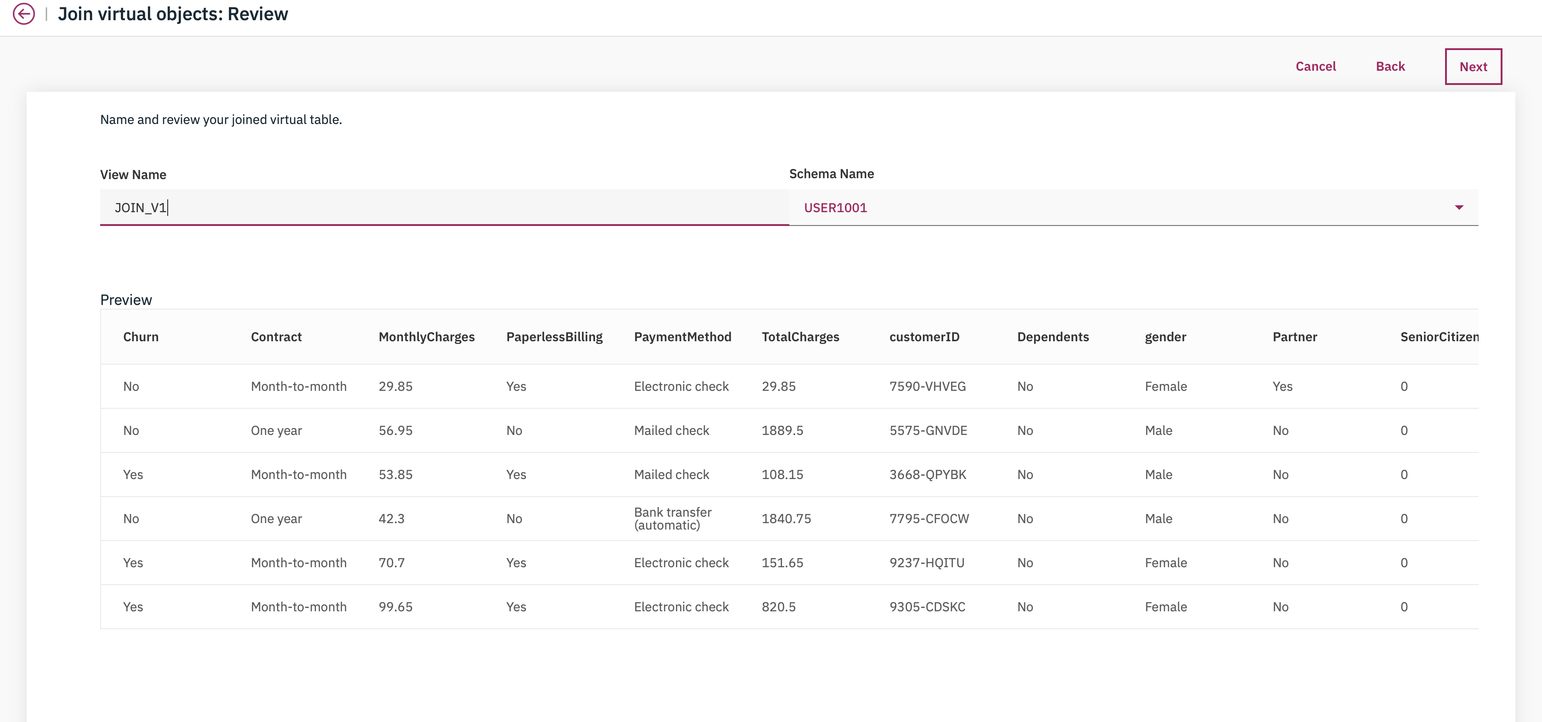

* 1. Click “Next”. This will bring to “Join virtual objects:Assign” screen. Under “Assign to”, select “None” option. Under Publish to catalog, select “No”. Finally click “Create view”

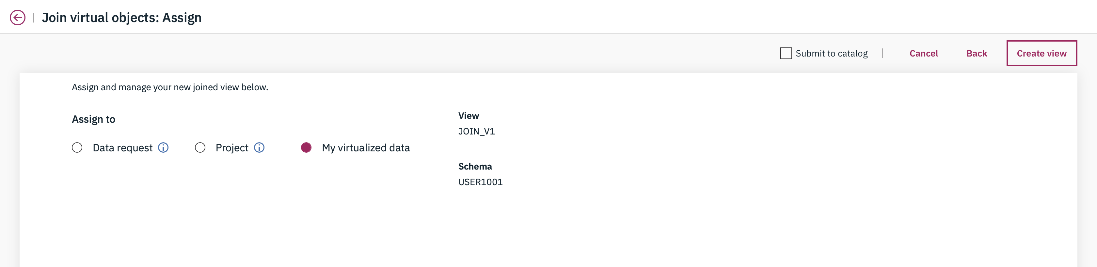

* 1. This will bring confirmation screen, showing the join has been created.

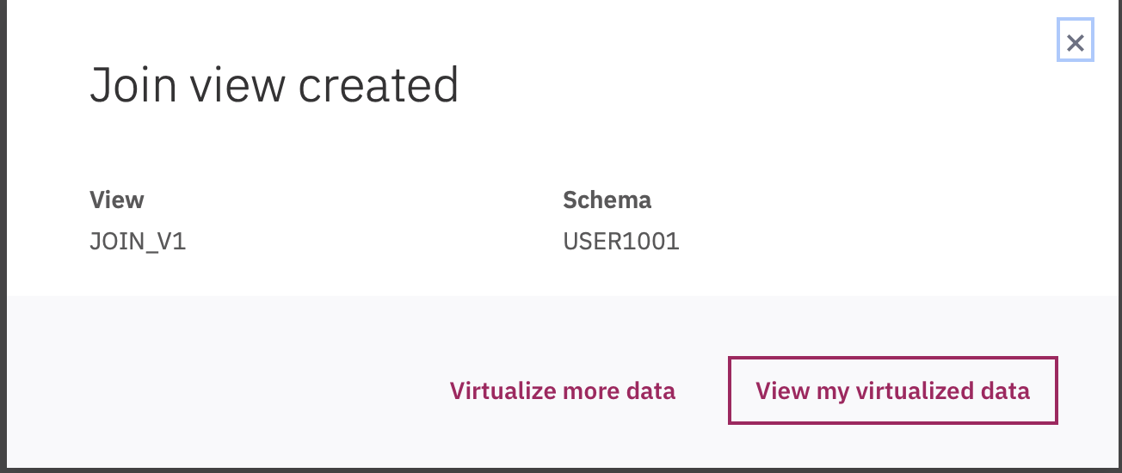

* 1. Click View my virtualized data, to verify.

You can use the virtualized data in several different ways. For example, you can use them in a Jupyter notebook, create new models within the Model Builder, or build charts or graphics on the analytics dashboard or Cognos analytics dashboard.

## Assign assets to a project

* 1. Click on Home menu “Collect” option, then click on “data Virtualization” . This will bring DV screen. Click on “Menu” and then on “My virtualized data”

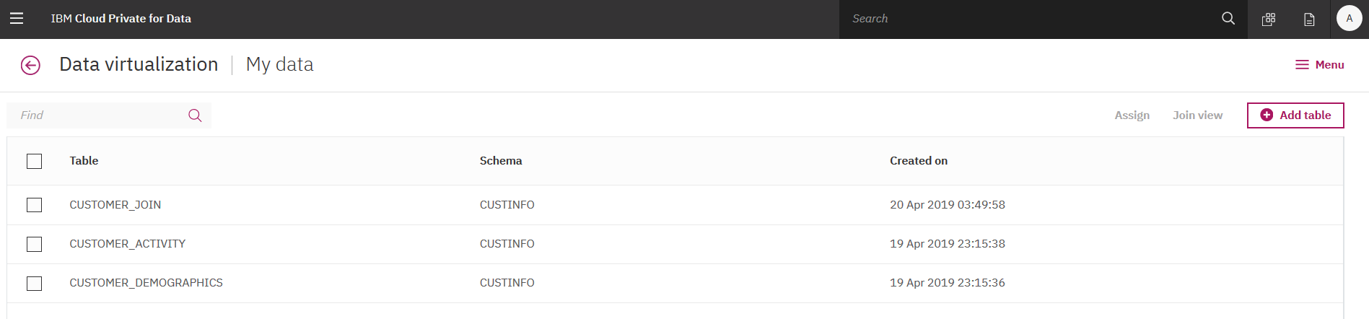

* 1. Select the JOIN_V1 table. Click “Assign”

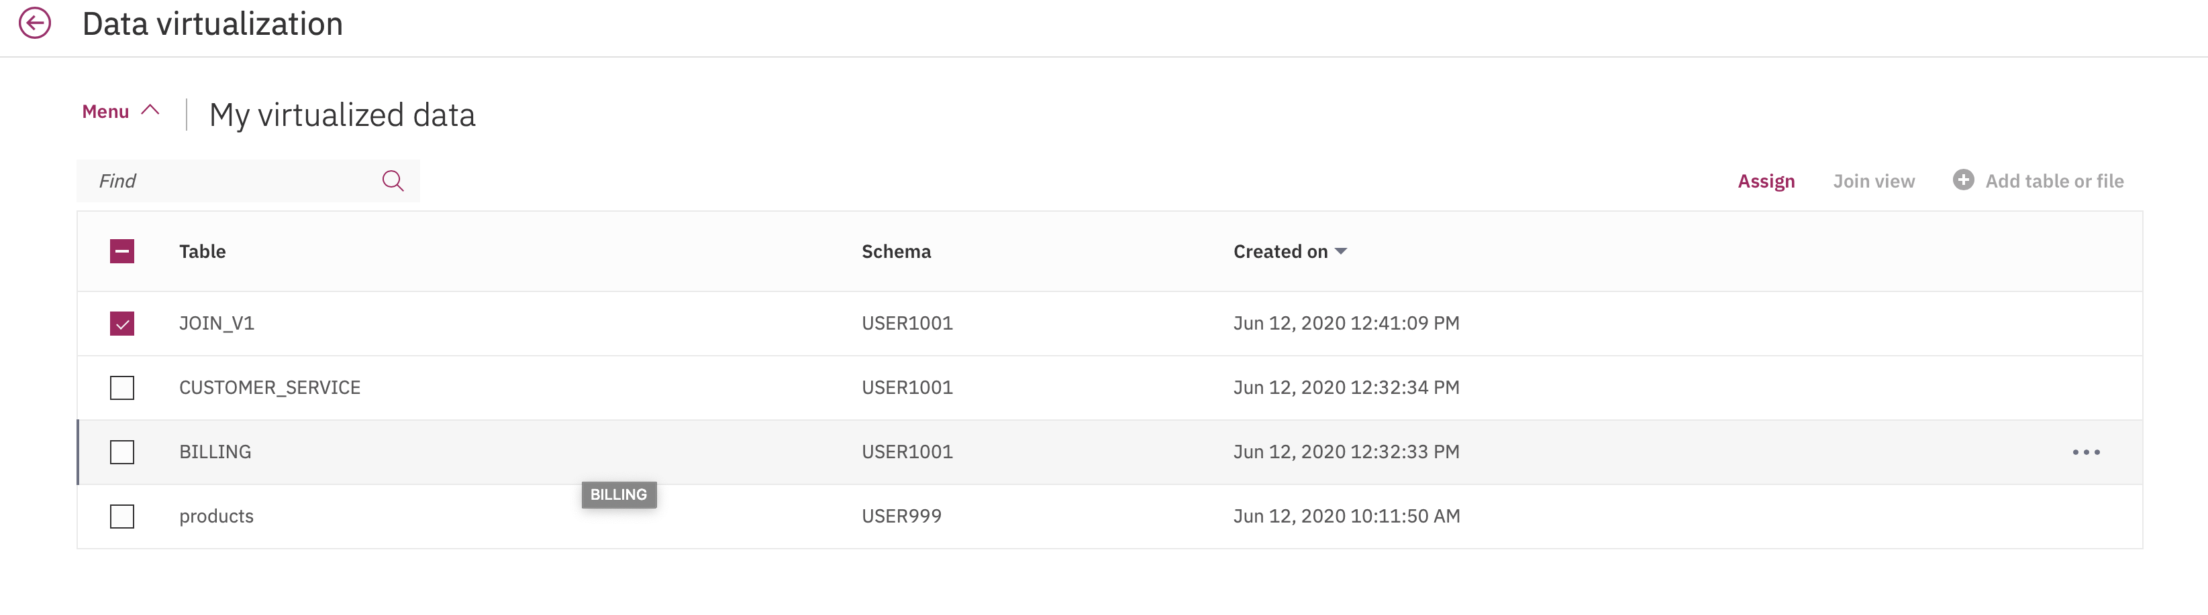

* 1. This will bring Assign screen. Select Project radio button and select your project name ( for e.g. DXC_sample). Click “No” for Publish to catalog option. Click “Assign”.

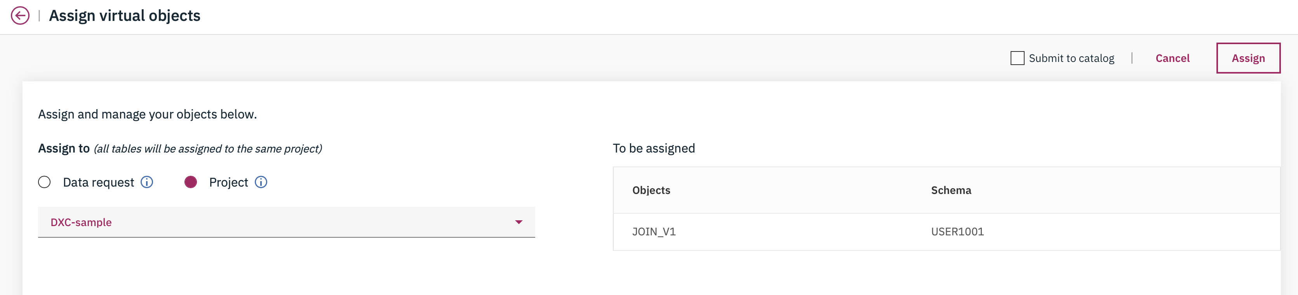

* 1. This will bring up a confirmation screen as shown below :

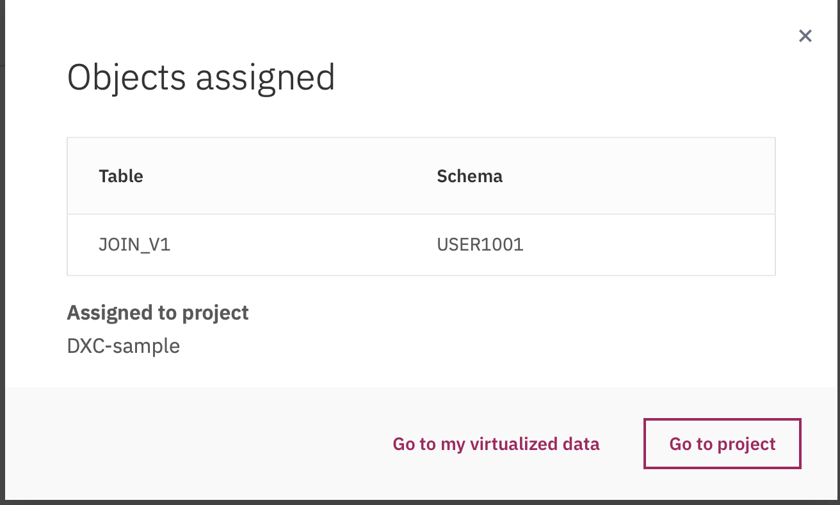

* 1. Click on Go to my virtualized data screen or Go to project to verify.

## Collaborate with various user personas

* 1. Click on Home menu “**Collect**” option, then click on “**data Virtualization**”. This will bring DV screen. Click on “**Menu**” and then on “**My virtualized data**”
  2. Select JOIN_V1 table, hover over to right side until you see 3 dots menu option.

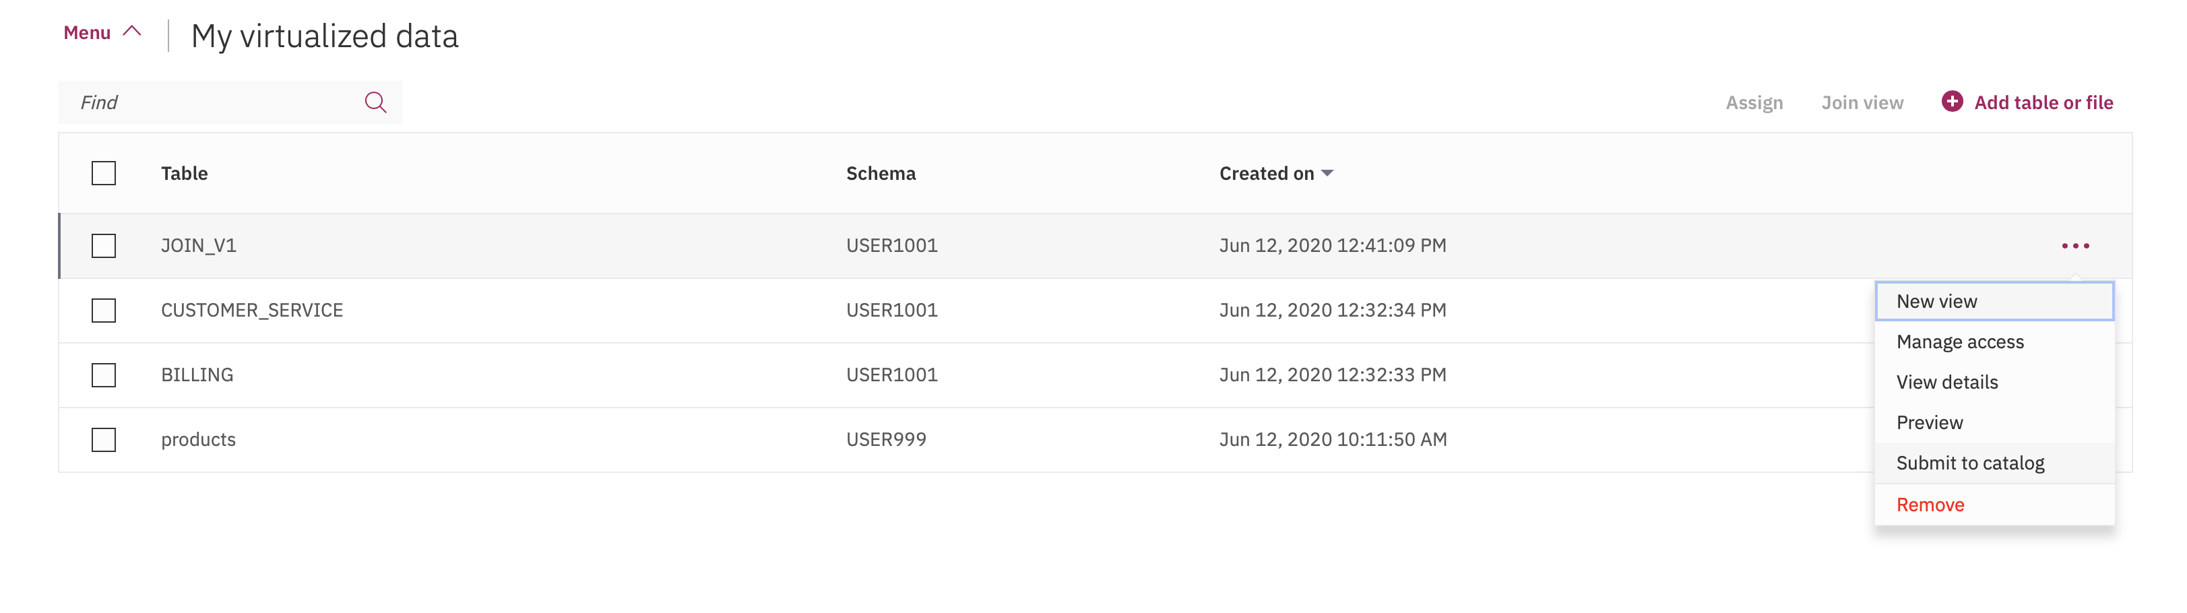

* 1. Select the options next to CUSTOMER_JOIN and choose “**Submit to catalog**”.

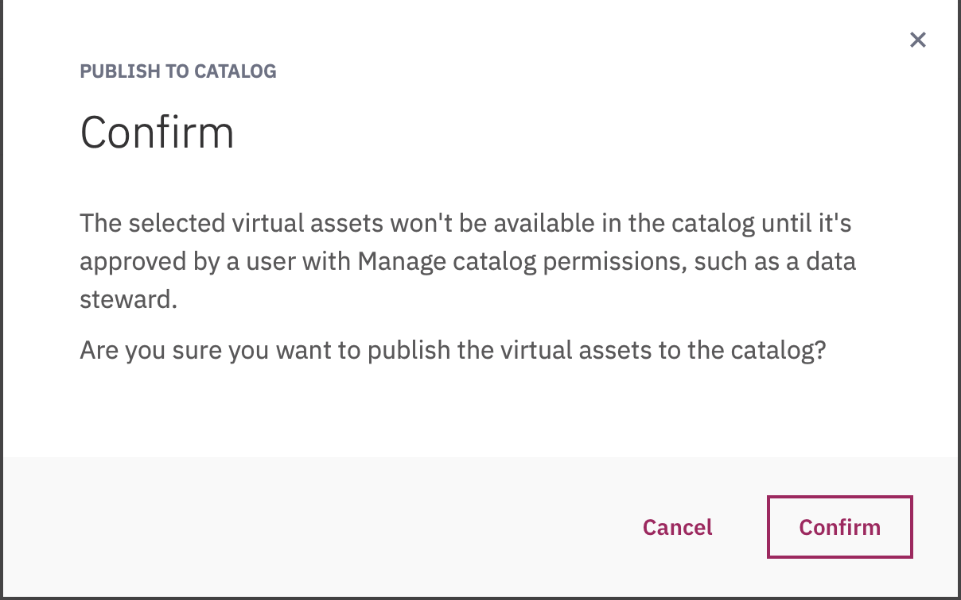

* 1. This will pop up a Conformation screen that a user with “Manage catalog” permission such as data steward needs to approve the request to be visible in the data catalog. Click “**Confirm**”
  2. Logout and login with user dsteward / password

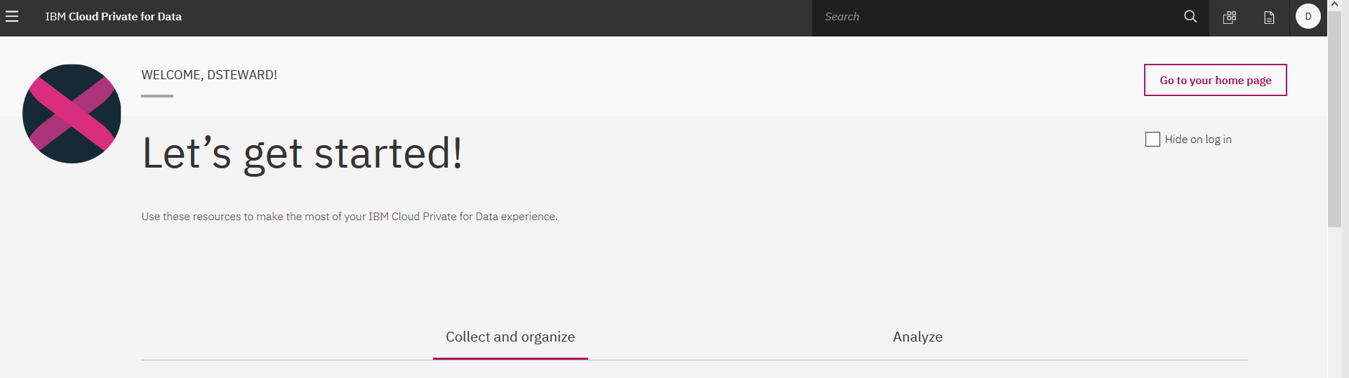

* 1. Click on “Go to the Home page” option on right top of the screen.This will bring up the screen with “1 Pending Publish to Catalog” option on the screen.

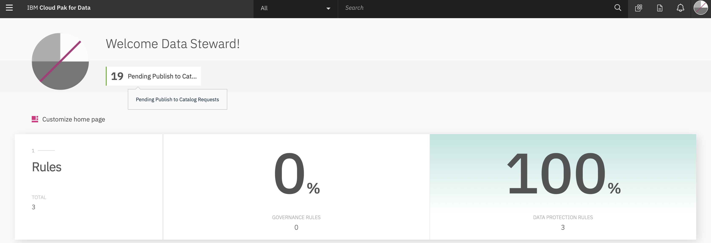

* 1. This will bring the USER1001.JOIN_V1 in the list of views with Status as Pending. Hover over to right of “Pending” to 3 dots options menuClick to the options menu and Click on Approve.

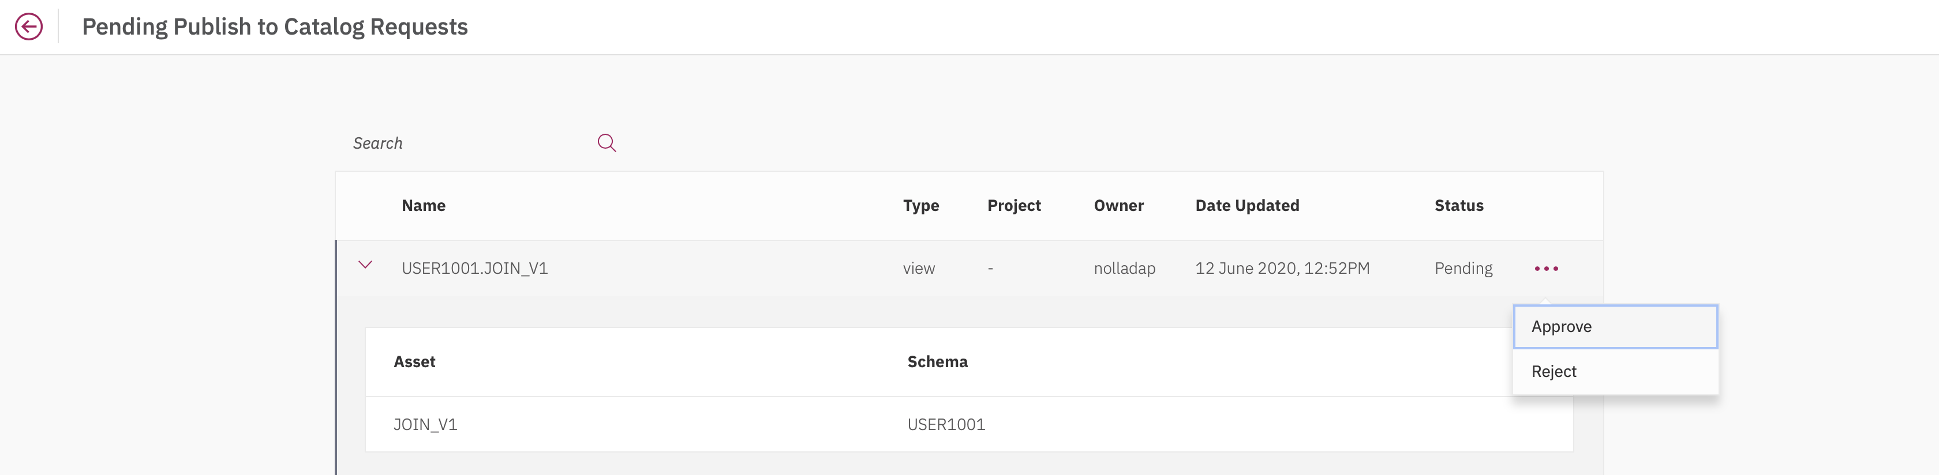

* 1. This will bring confirmation pop-up screen. Enter any optional comments in the box and click “Approve”

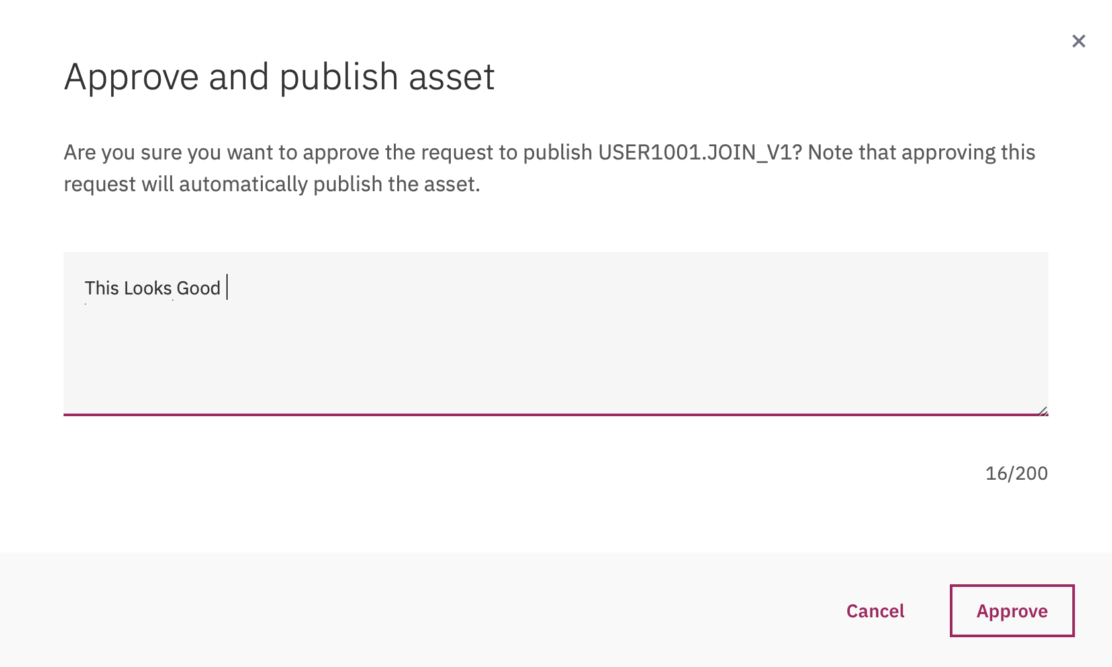

If the current logged-in user has not been given permission within DV as “Engineer” then you may get a message like :



Make sure the user has been added to DV, before re-attempting to publish.

* 1. After successful publishing, you will get confirmation screen as shown below:

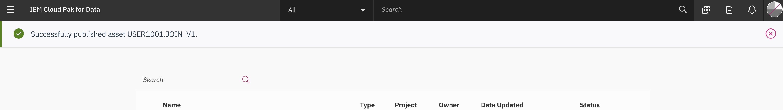

* 1. Go to Home menu, select “Organize” and then “All Catalogs” option
  2. Drill down to the Assets and see USER999.JOIN_V1

## Approve Data Requests

* 1. Click on Home menu “**Collect**” option, then click on “**My data** ”. This will bring DV screen. Click on “**Data requests**”

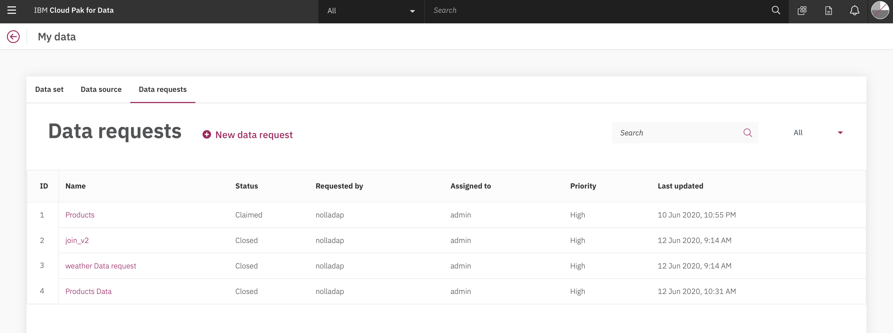

* 1. Click on New data request

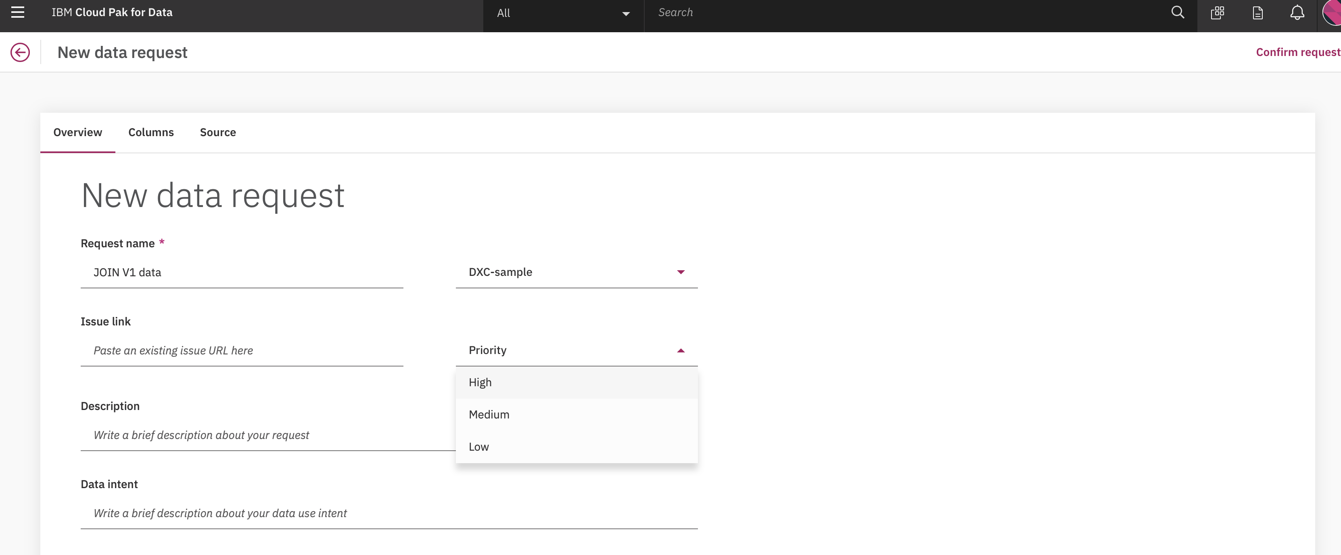

* 1. Click on Columns and add the requested data columns and their type and description (optional)

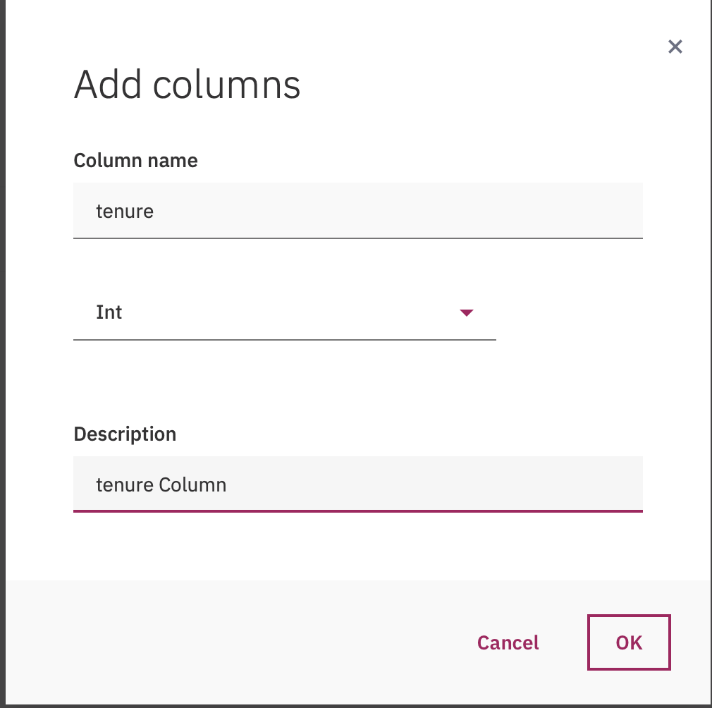

* 1. Click on Source from where the data is requested(optional)

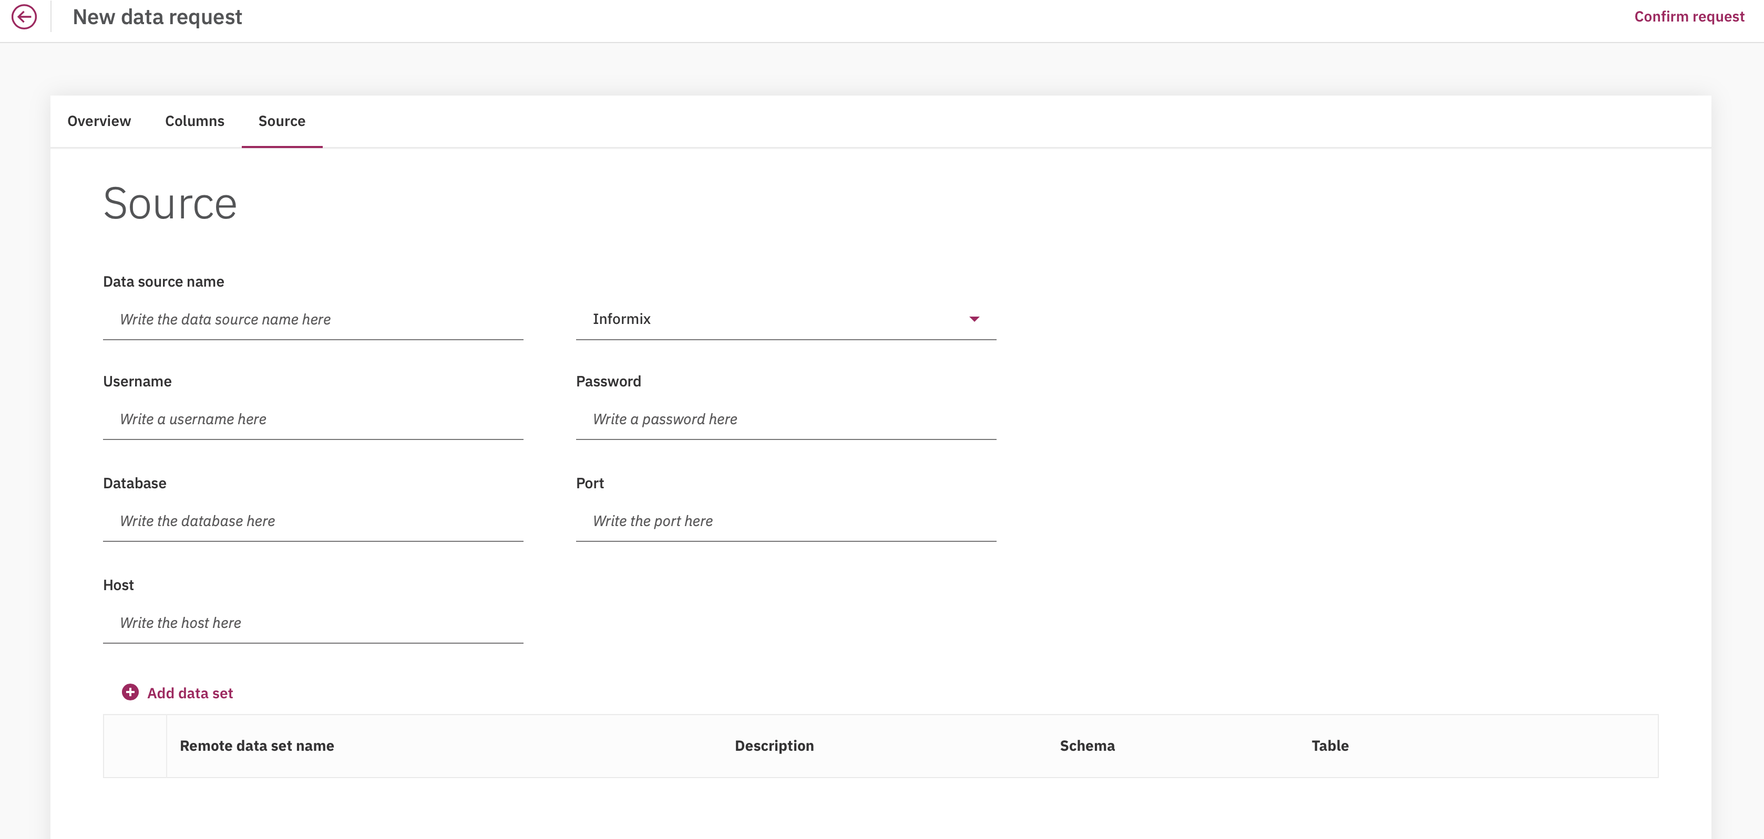



* 1. Click on Confirm Request and Submit Request
  2. The request would Create with Status as New and someone (Data Admin/Data steward) will assign to themselves and deliver your request.

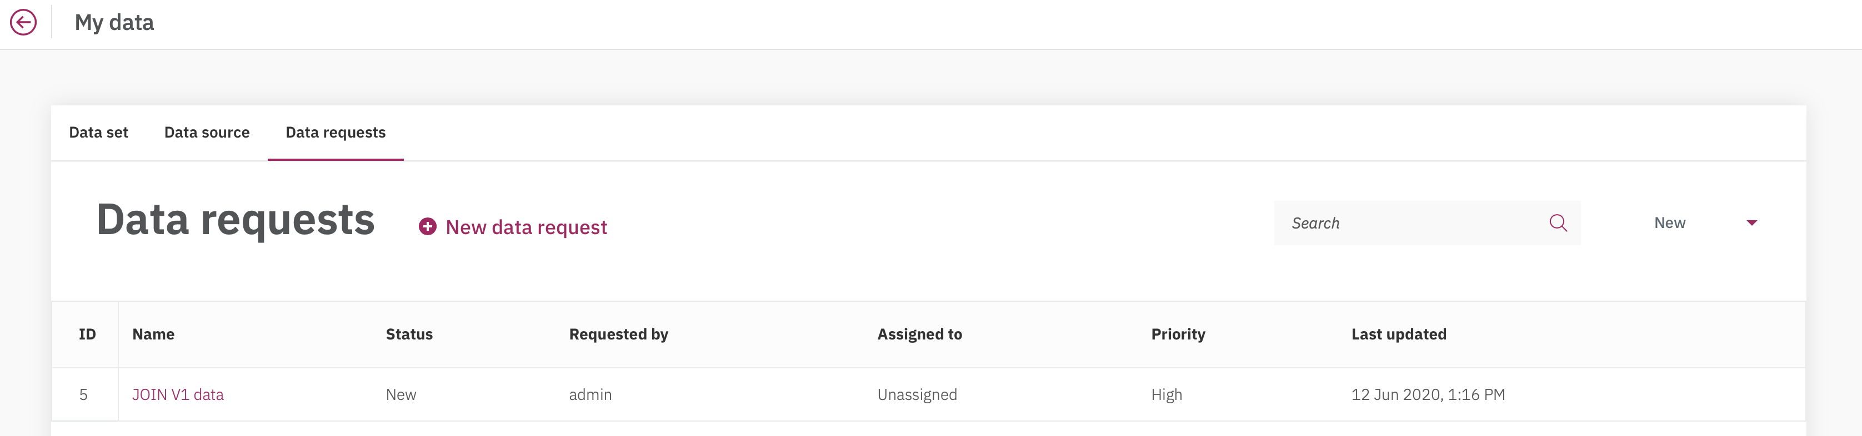

* 1. Logout and Login back as Data Steward in cloud pak for Data
  2. Click on Home menu “**Collect**” option, then click on “**My data**”. This will bring Data requests. Click on the JOIN V1 data request

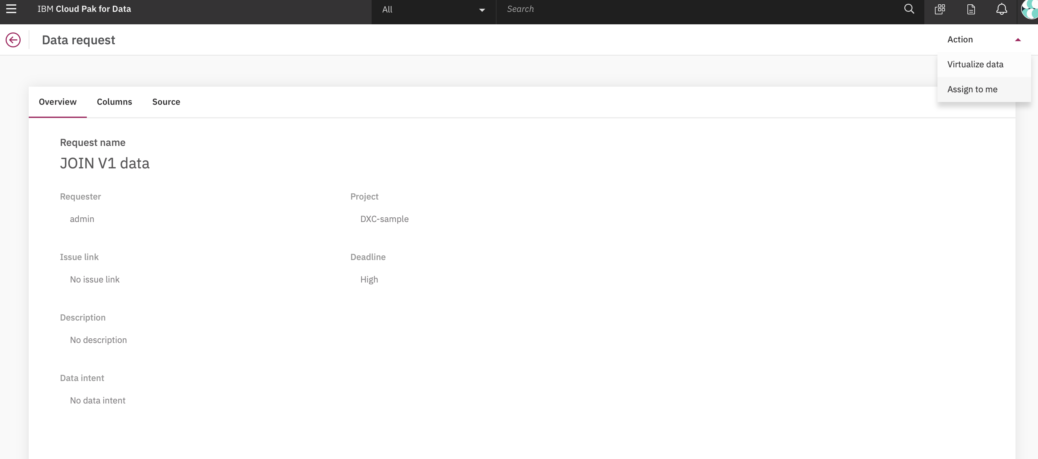

* 1. Click on Home menu “**Assign to me**” option, then click on “**ok**”. This will successfully assign the Data request to you



* 1. Click on Home menu “**Collect**” option, then click on “**data Virtualization**”. This will bring DV screen. Click on “**Menu**” and then on “**My virtualized data**” and select the request data Asset and Click “**Assign**”.

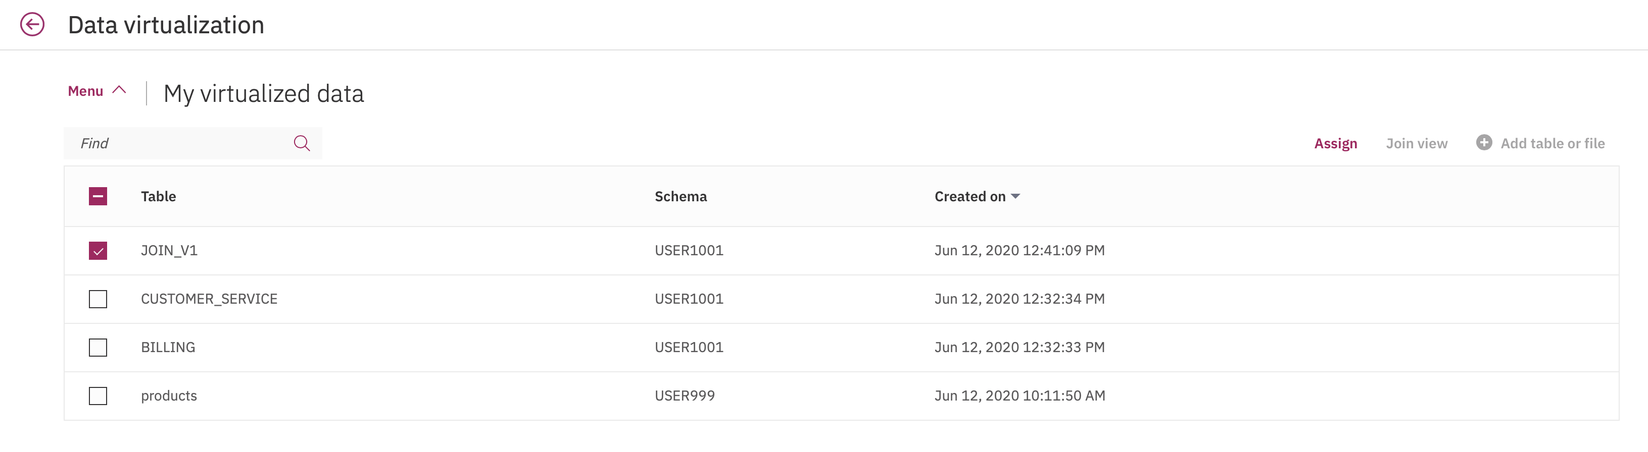

* 1. Click on Data Request and select the Data request picked up by you and Click Assign

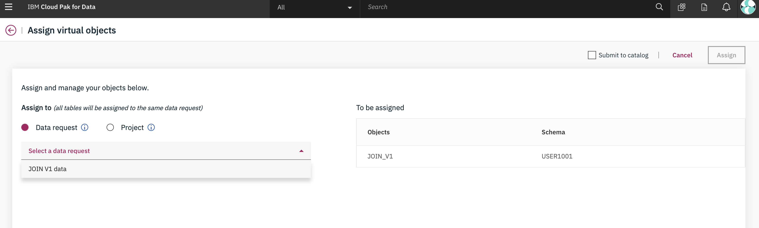

* 1. Click on Confirm Request and Submit Request

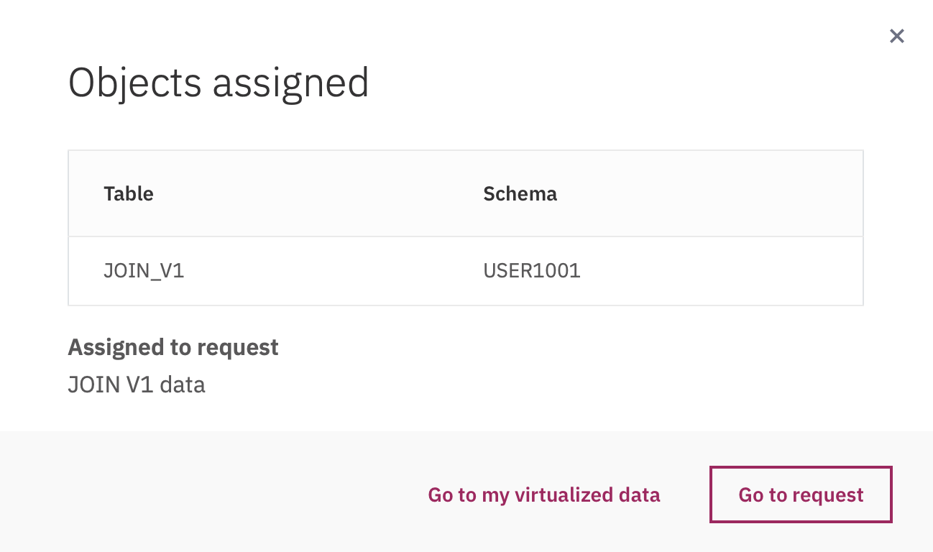

* 1. Click on “**Go to request**”.

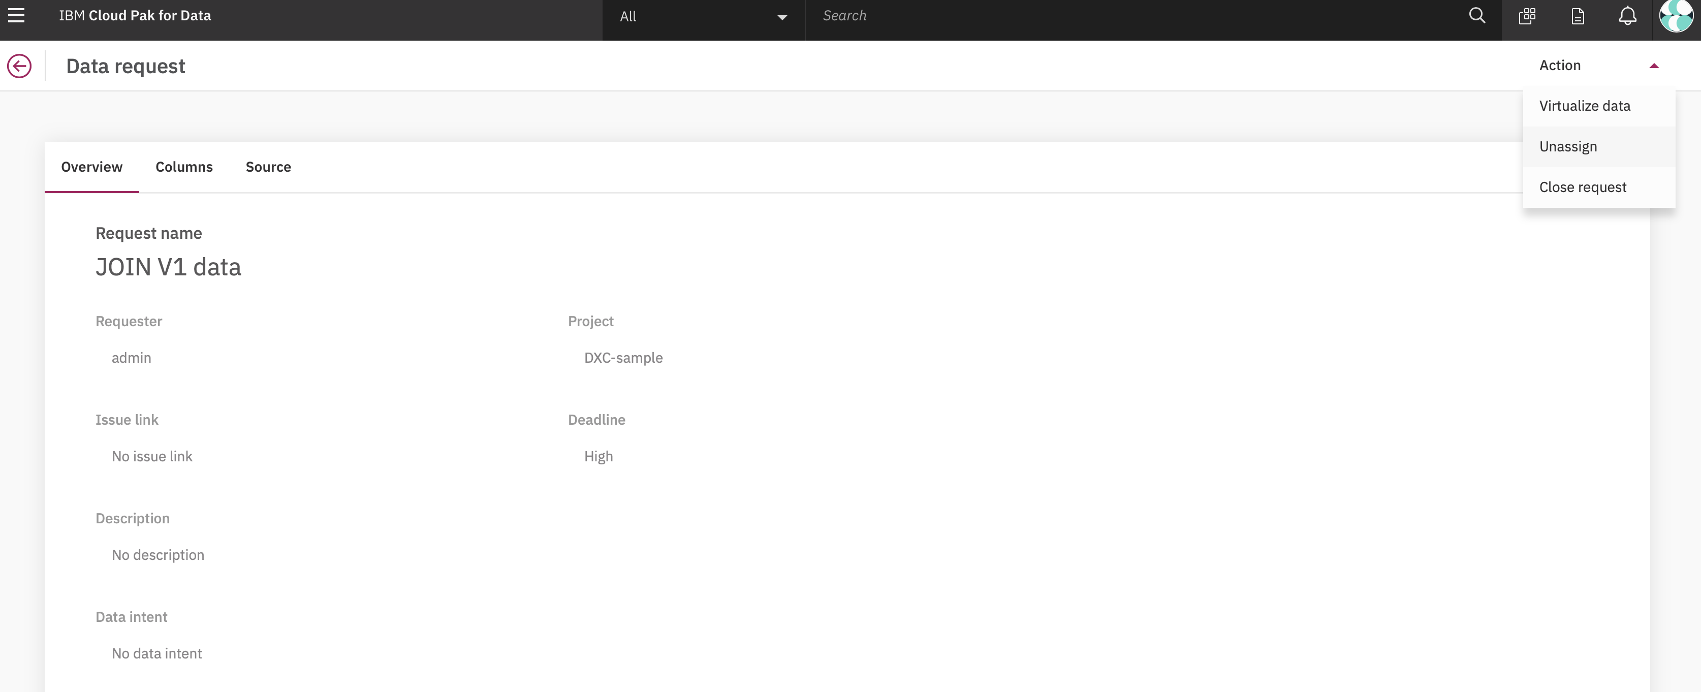

* 1. Click on “**Close Request**”.
  2. Login as Data Scientist and try accessing the virtualized Data.

# Bonus

Try virtualization on different databases:

